Marlin Golden 39A Lever Action .22 Rimfire
By Randy Wakeman

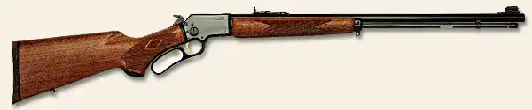
Illustration courtesy of Marlin Firearms Co.
Billed as the oldest continuously manufactured rifle in the world, the Marlin 39 began life as John Marlin's Model 1891 (used by Annie Oakley), redesigned as the 1897, then the Model 39 in 1922. The "39A" designation appeared in 1939. The "third variation" of the Model 39 series appeared in 1946, the fourth variation added a fluted comb, the fifth variation was introduced in 1951, and Marlin's "Micro-Groove" rifling appeared in 1953. The "redesigning" is generally considered so slight that the rifle is regarded as essentially the same article for over the last 100 years with in well in excess of two million produced.
Forged steel parts set this rifle apart from many in the pack. It remains my favourite .22 lever-action rifle. With a capacity of 19 .22 LR rounds, you can load up and hunt for a long while without fumbling for clips or otherwise bothering to reload.
The 24 inch barrelled version has enough heft and feel to make it very easy to shoot well. And, shoot well it does. With CCI Velocitor ammo, my 39A shoots into an inch at 100 yards. Using Lapua Speed Ace or Lapua 36 gr. HP ammo it groups tighter yet. More accuracy than you need, really more accuracy than you can use for common sub-75 yard small game hunting.
New Marlin triggers are a bit on the heavy side, but with use they seem to lighten up a bit. My current rifle breaks at a repeatable 3 lbs. 9 oz., with no take-up or sand, perfectly acceptable for any of my purposes.
Feeding, extraction, and ejection are flawless with most ammo I've tried. I'm trying to remember if I've ever had a failure to extract; I don't recall any. The street price of the 39A has crept up to the $475 area. With forged and machined parts, solid walnut stocks, and attractive bluing, the quality of both raw materials and finished product are self-evident.
In this age of the false economy of skimping on firearms themselves and the proliferation of plastic and stamped steel parts, it is refreshing to shoot and enjoy an American Classic that has not sacrificed quality, heft, and feel for the sake of trendiness. The Marlin 39A remains my favourite lever action rifle of any type and one of the finest .22's made. Not much can replace the feel of walnut, the look of bluing, the fit of machined forgings, and the robustness of the Marlin 39A's design.
Comparatively few rifles, especially .22's, give me the feeling that they can (or should) be passed down through the years for generation after generation to enjoy. The Marlin 39A achieves that rare, precious distinction as both best of breed, and one of the best ever.

